Domestic Abuse Resource Order Form

Resource | Image | Number requested
A4 Male Victim Poster | 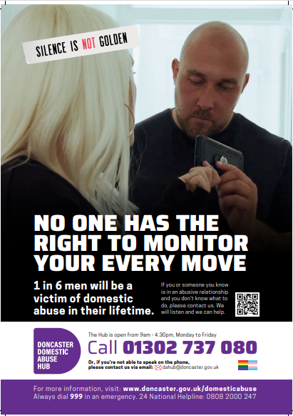
A4 ‘No one has the right to make you feel that you can’t speak out’ Poster | 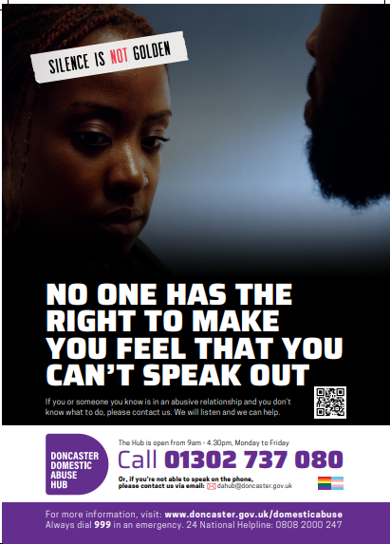
A4 ‘No one has the right to exploit your vulnerability’ Poster | 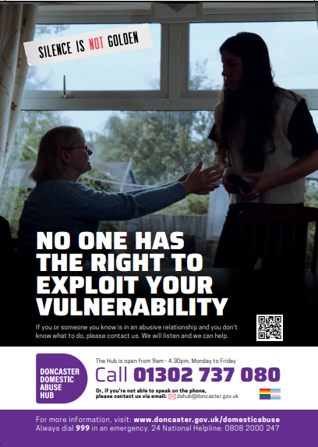
A4 ‘No one has the right to make you feel like a prisoner in your own home’ | 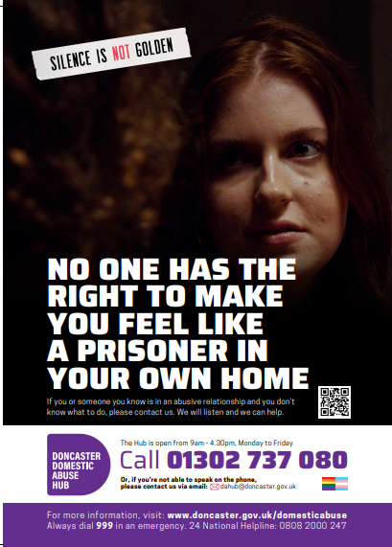
LGBT+ Poster | 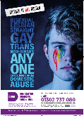
Domestic Abuse Services Leaflet | 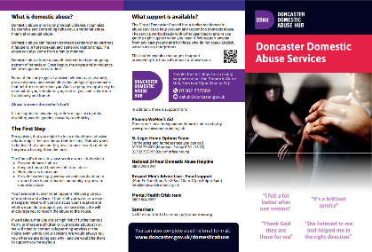
Safety Booklet | 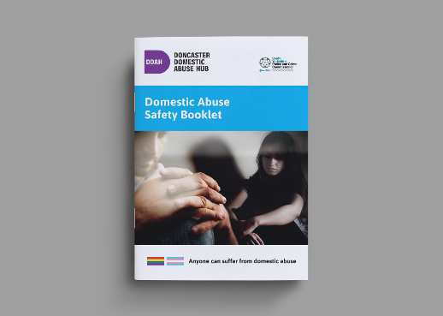
Practitioner booklet | 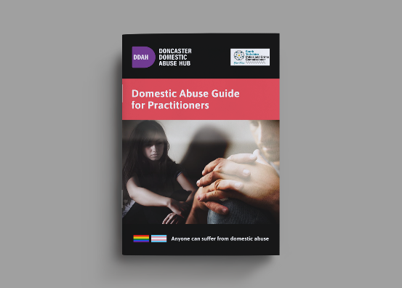
Stalking and harassment A4 and A3 posters | 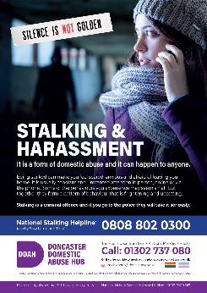 | Please specify whether you want A4 or A3
Stalking and harassment A4 and A3 posters | 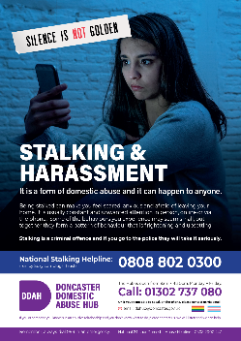 | Please specify whether you want A4 or A3
Familial abuse | 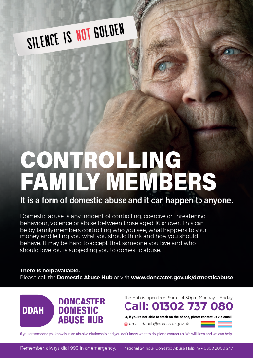 | Please specify whether you want A4 or A3
Talk to the badge - Nurse | 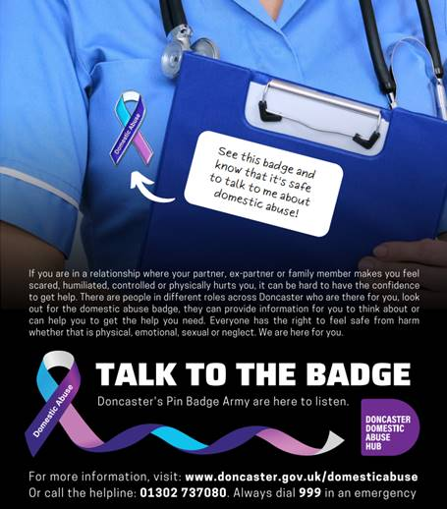
Talk to the badge – Male shirt | 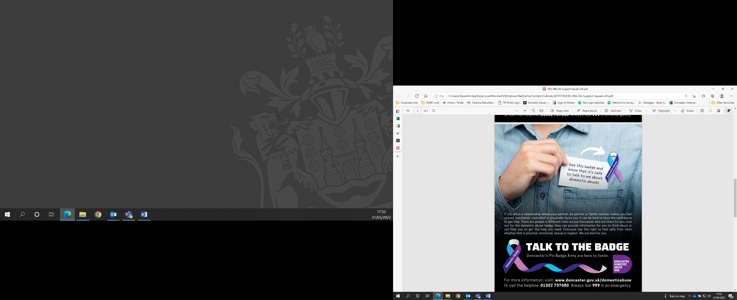
Talk to the badge – woman suit | 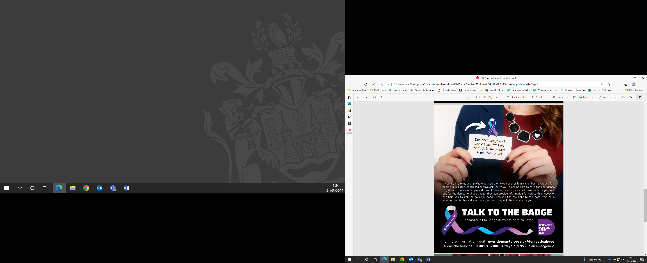
Talk to the badge – man workgear | 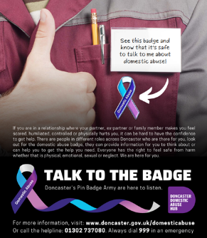
Talk to the badge - hoodie | 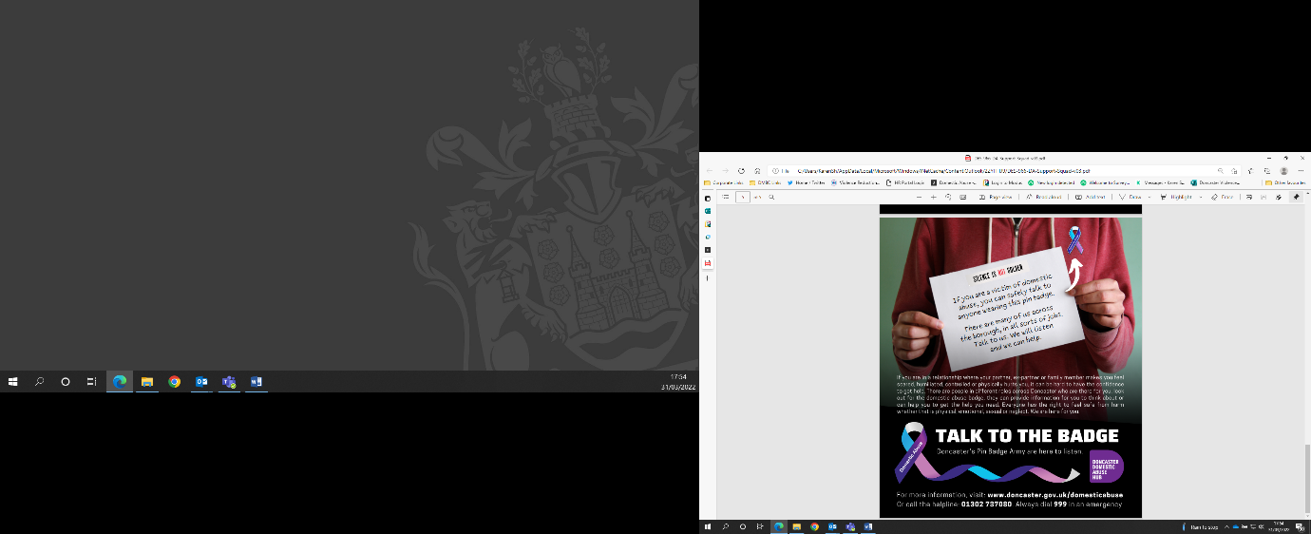
Barcodes – 65 stickers per page | 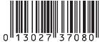 | [ ] pages of stickers

Please do not order more than you need. Publicity material will be changed on a regular basis to keep the message alive and ensure they contain the correct information.

Large order will be available for collection from the Mary Woollett Centre. Smaller orders can be posted. Please provide contact details so that collection can be arranged when ready:

Name:
Job Title:

Agency:
Delivery address (for smaller orders):
Email address:
Telephone Number:
How do you intend to use the resources?

Where will they be displayed?

Please email the completed form to Sophie.bishop@doncaster.gov.uk

